Name: Arpit Mahalle
Milestone 2 Assessment output screenshots
User Story 1:
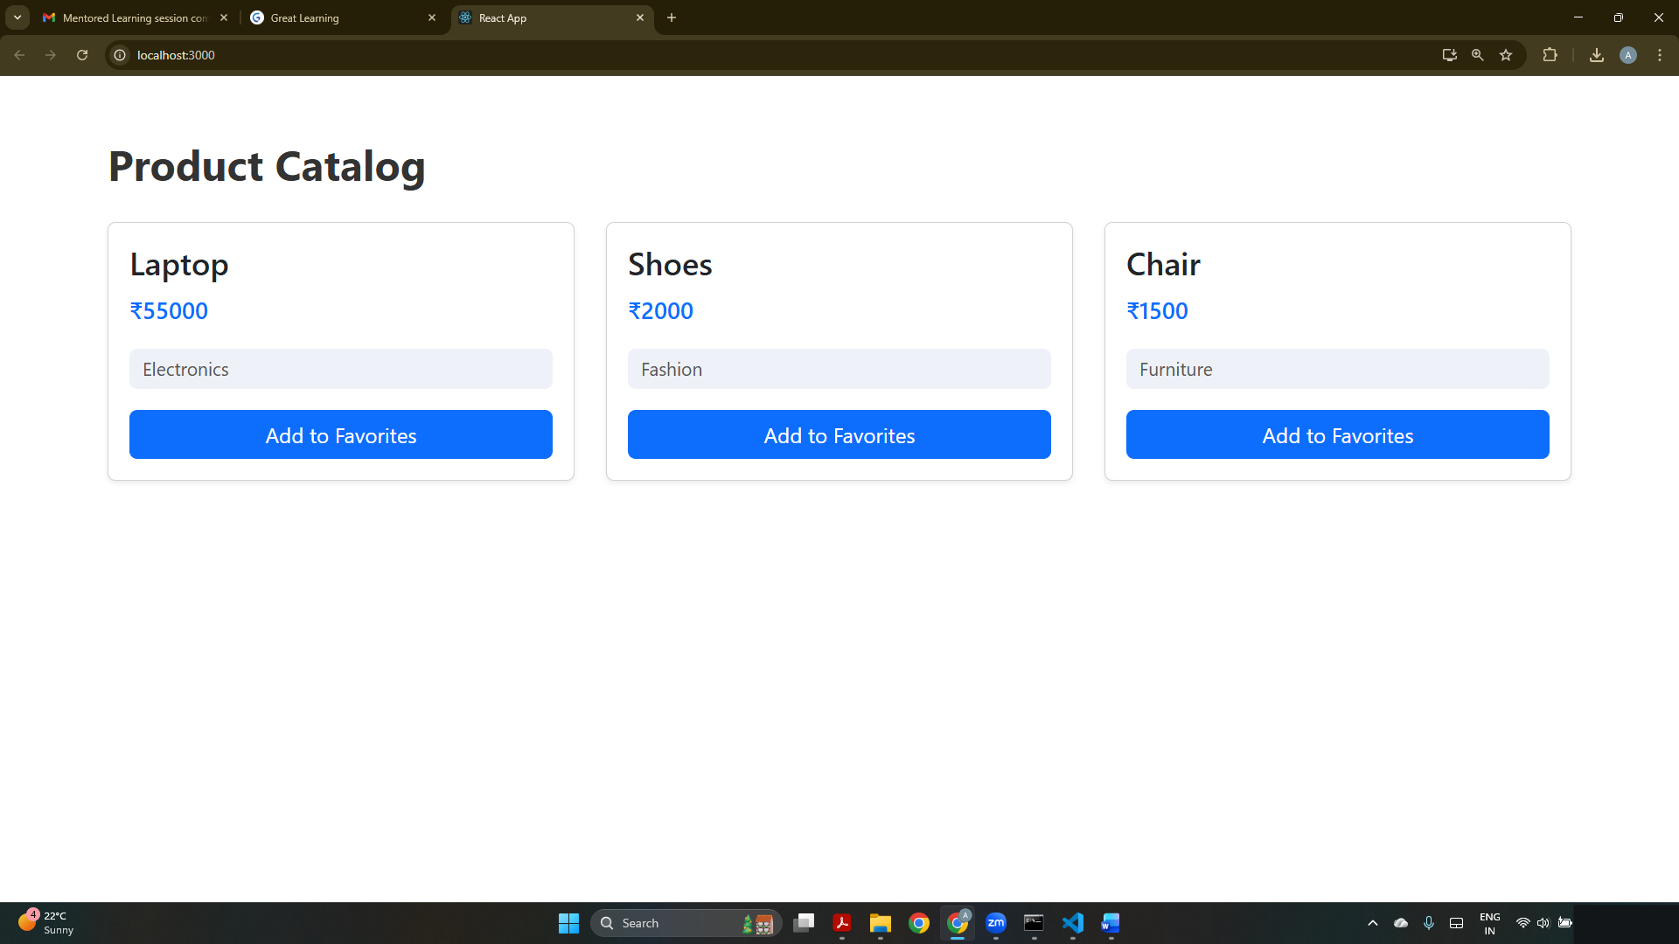
A basic React product catalog displaying static products with name, price, category, and an “Add to Favorites” button styled using Bootstrap.

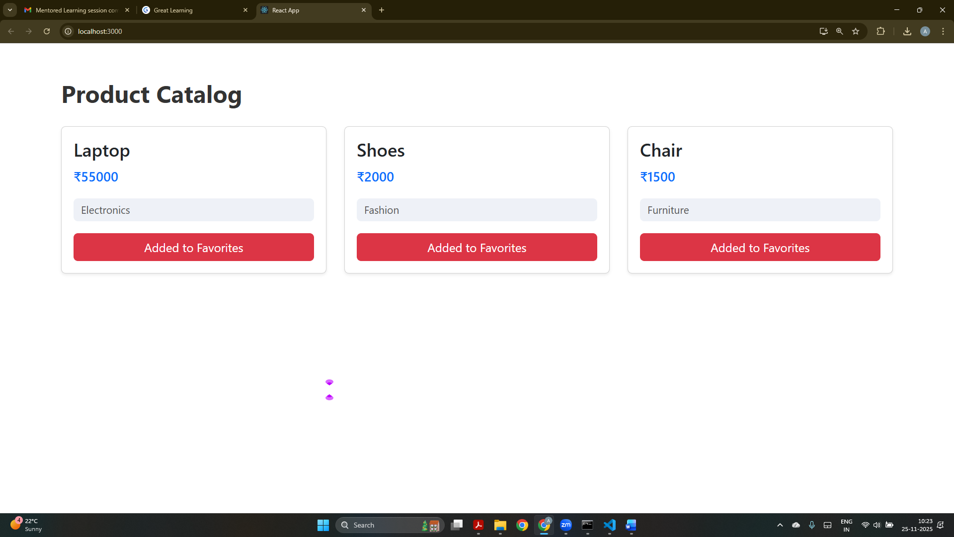
The favorite button changes style dynamically using React state, showing the updated UI when a product is marked as favorite.

User story 2:
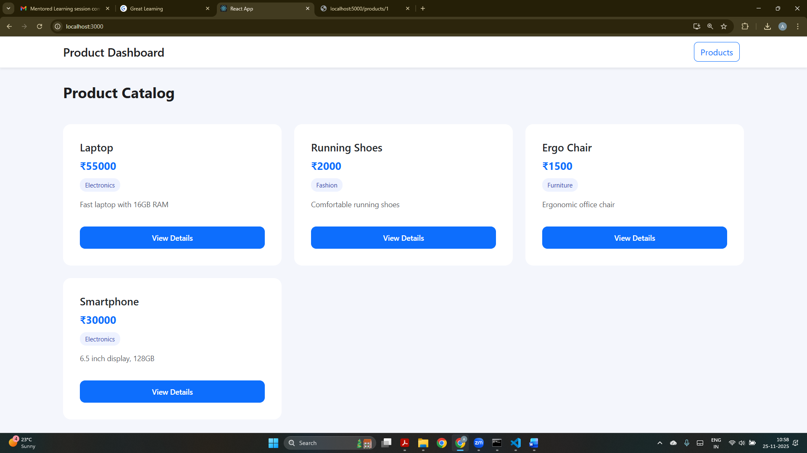
The product catalog now fetches product data from an Express backend and displays them using clean Bootstrap cards with “View Details” buttons.

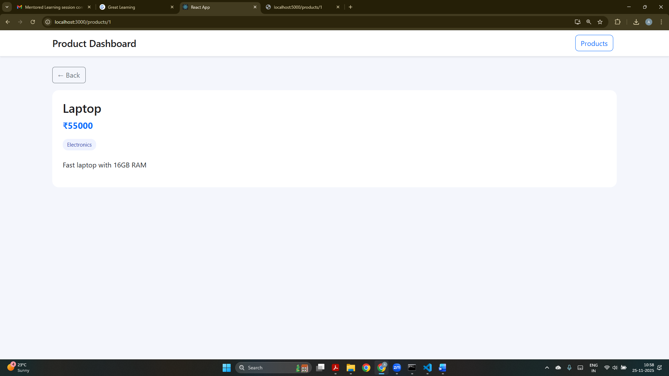
A detailed view of the selected product is shown using React Router dynamic routing (/products/:id) with Bootstrap styling.

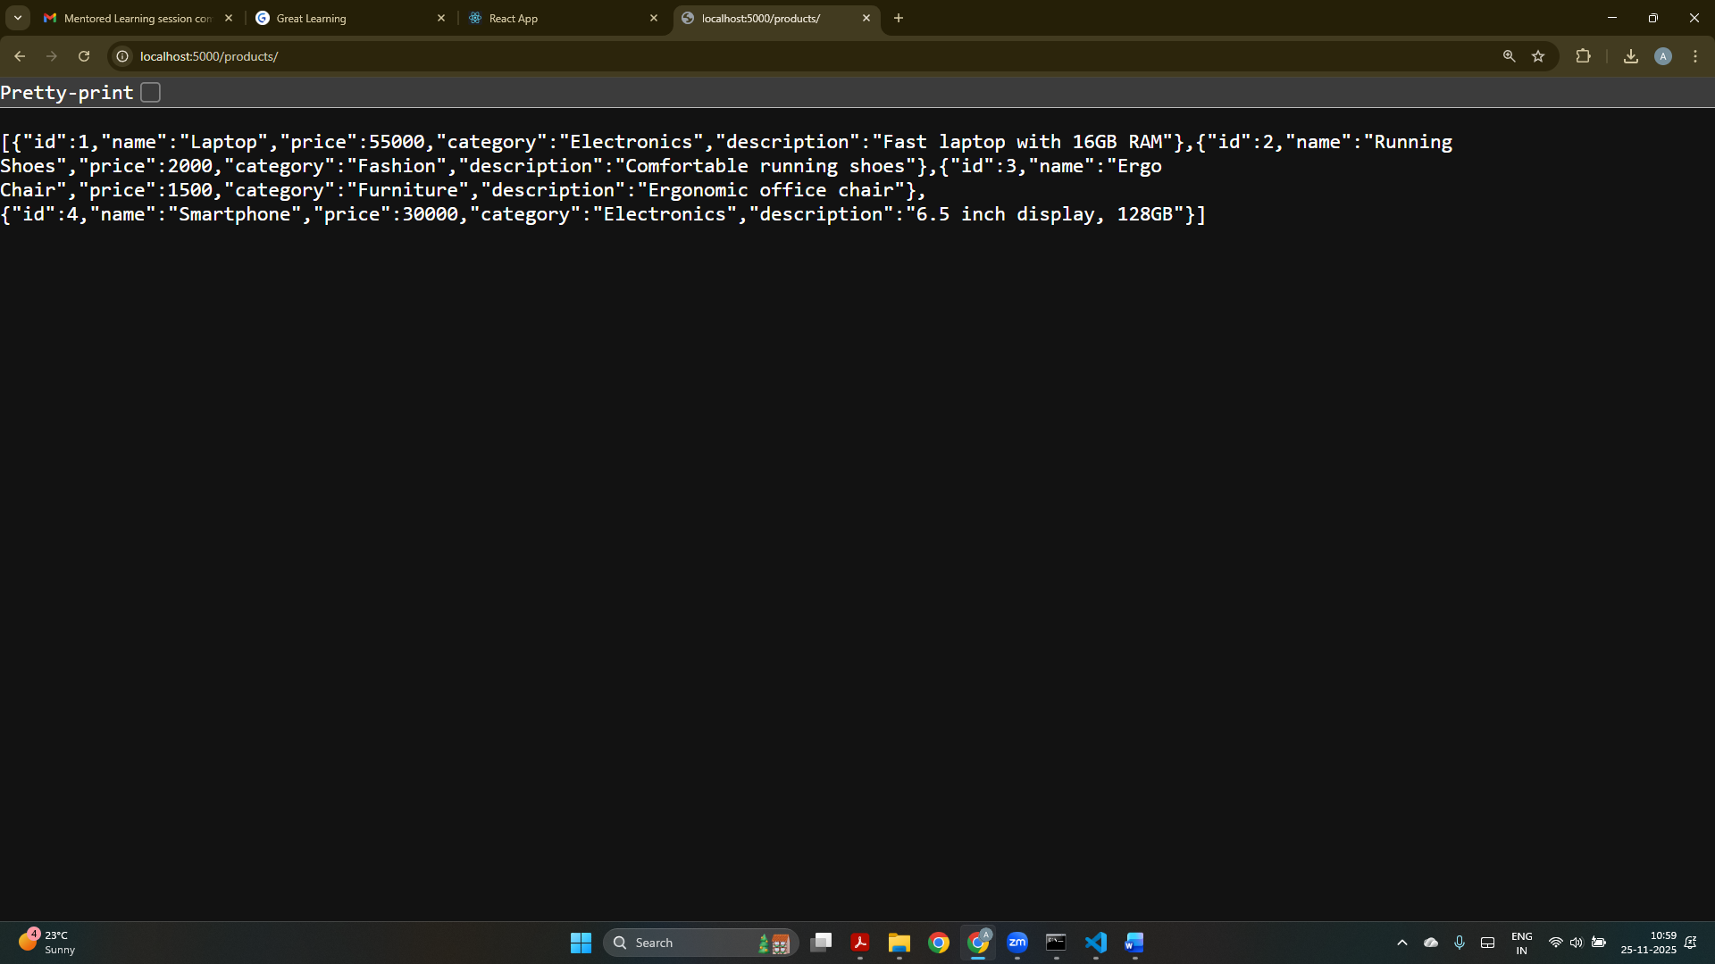
The Express.js backend returns the product list in JSON format through the /products API endpoint.

User Story 3:
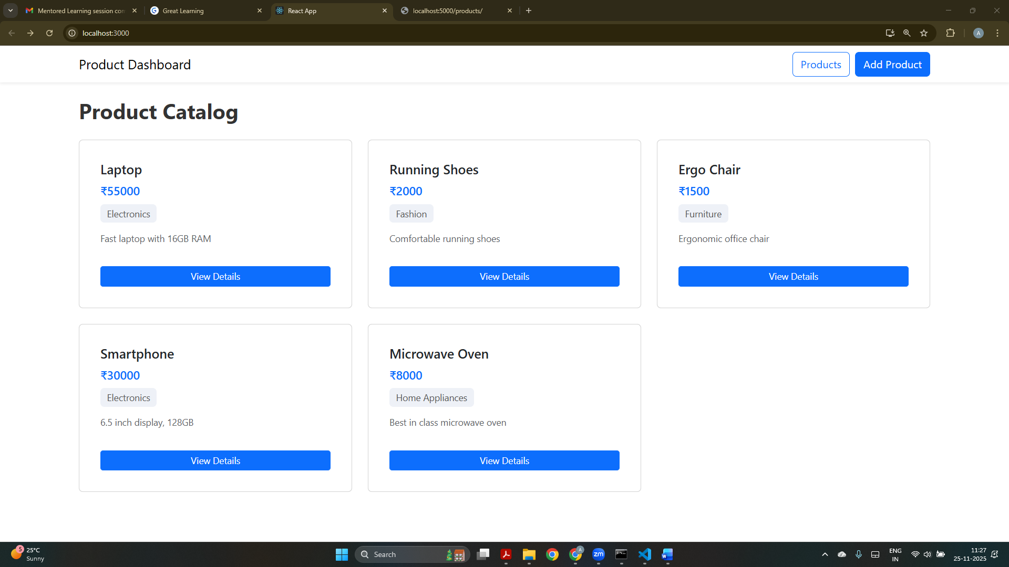
A newly added product appears instantly in the product list using Context API for global state and POST API integration.

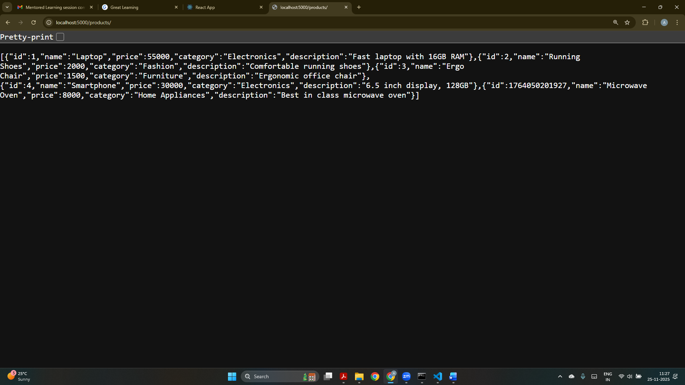
The Express backend now includes the newly added product in the updated /products response.

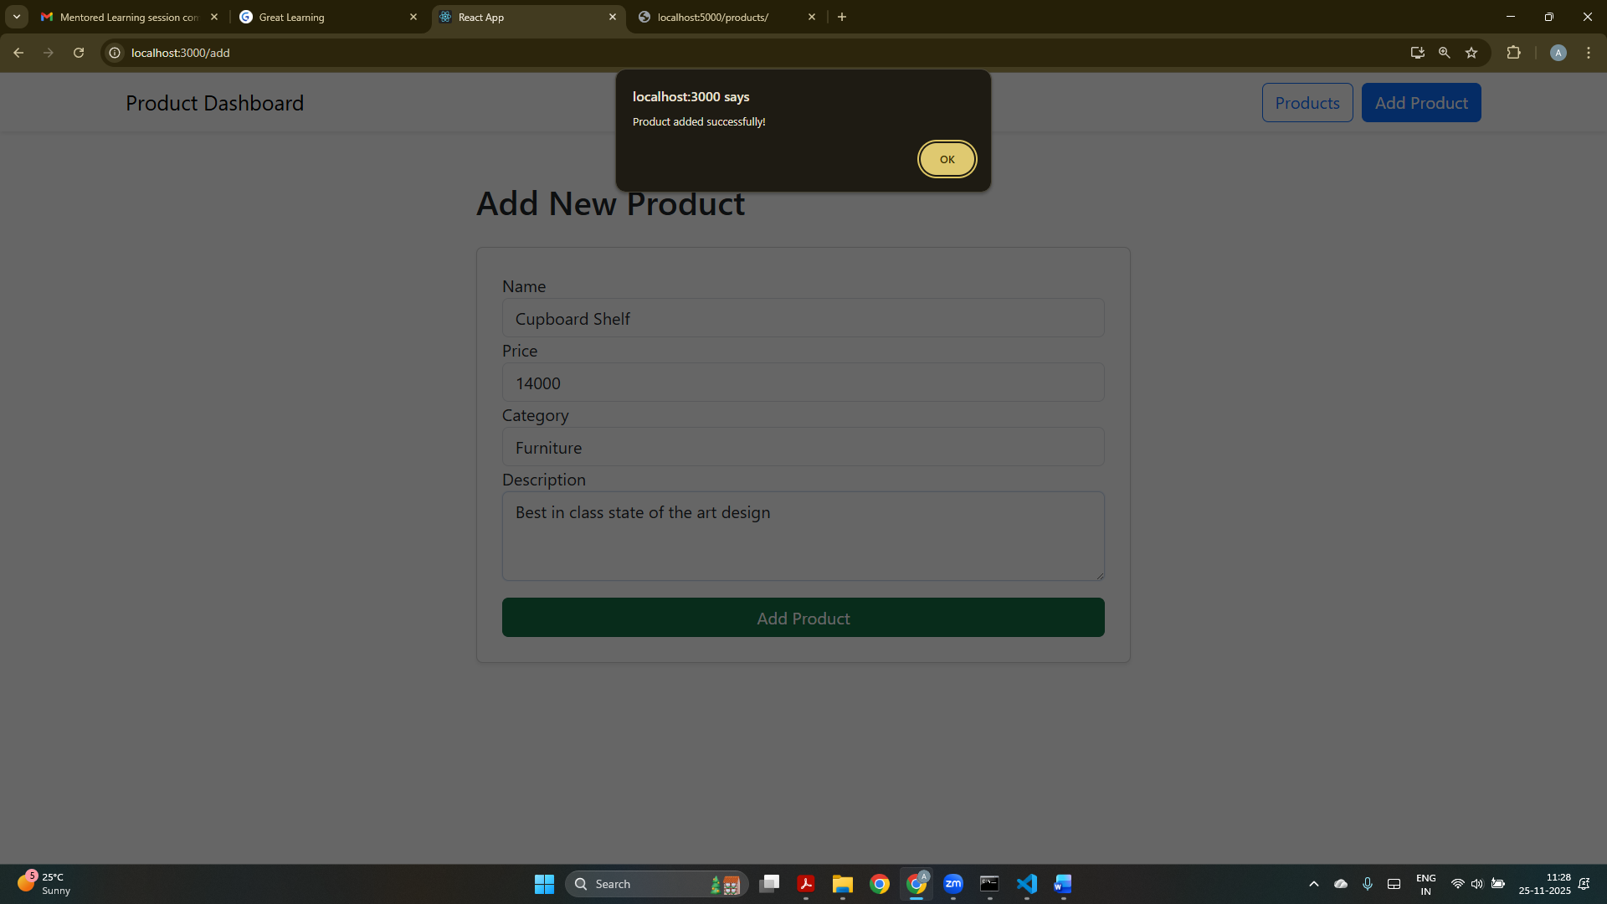
A Formik + Yup form allows users to add new products with validation and Bootstrap styling; success is shown via an alert.

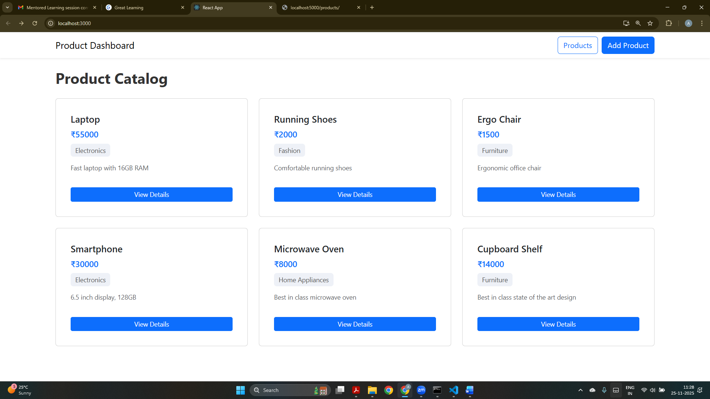
The product catalog updates immediately after adding a new product, showing real-time UI updates using Context API.
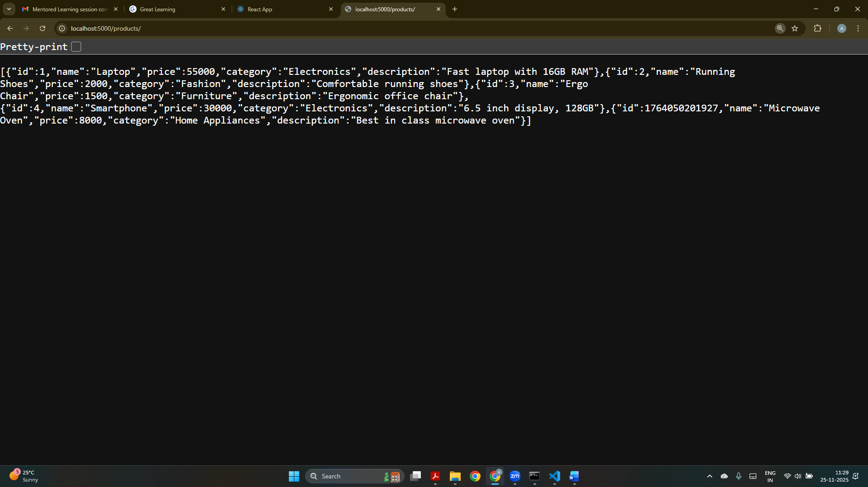
The backend JSON displays all products including newly added entries, confirming successful POST operations.

